1) **A company consists of departments. Departments are located in one or more offices. One office acts as a headquarter. Each department has a manager who is recruited from the set of employees. Your task is to model the system for the company. Draw a class diagram that consists of all the classes in your system, their attributes and operations, relationships between the classes, multiplicity specifications, and other model elements that you find appropriate.**

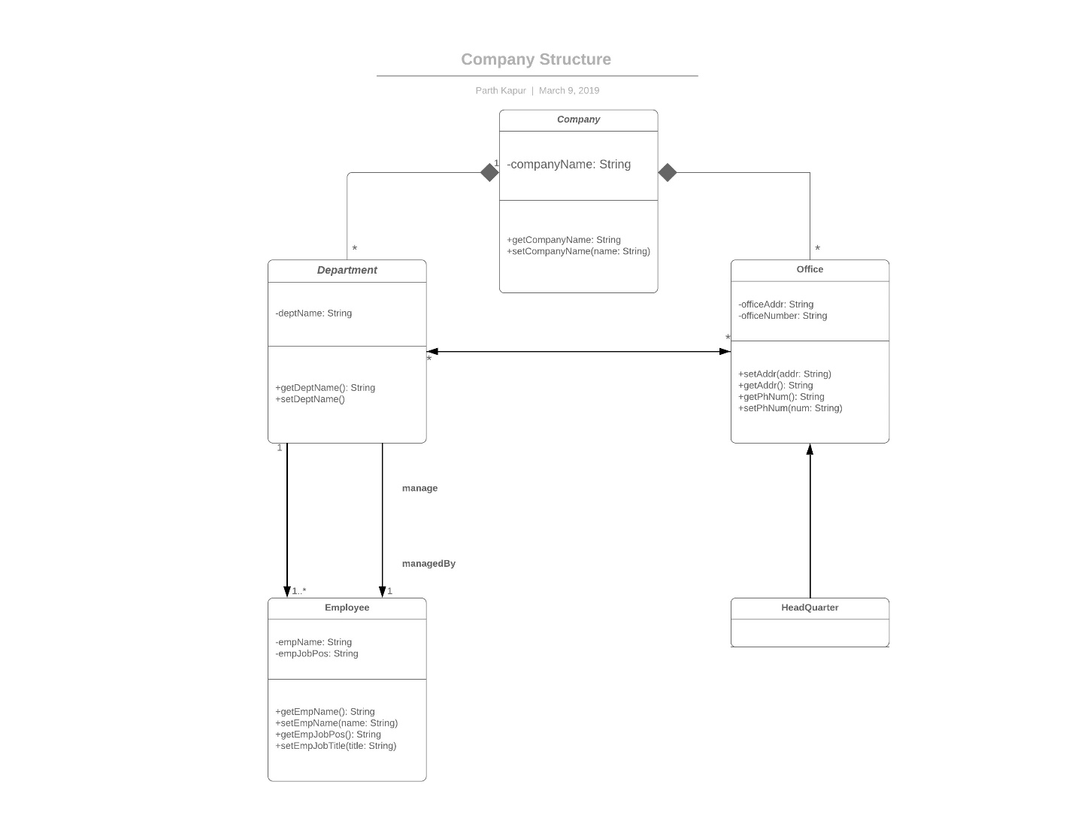

2a) **An automated ticket issuing system used by passengers at a railway station**

The architecture style known as blackboard style should be utilized. A ticket issuing system requires a central data structure (a database). Additionally, a collection of independent components which operate on this database is required. These components can include, but are not limited to, passenger information, price, ticket machine, and railway route. All these components are individually independent. However, they require being triggered by the current state of the central data structure. 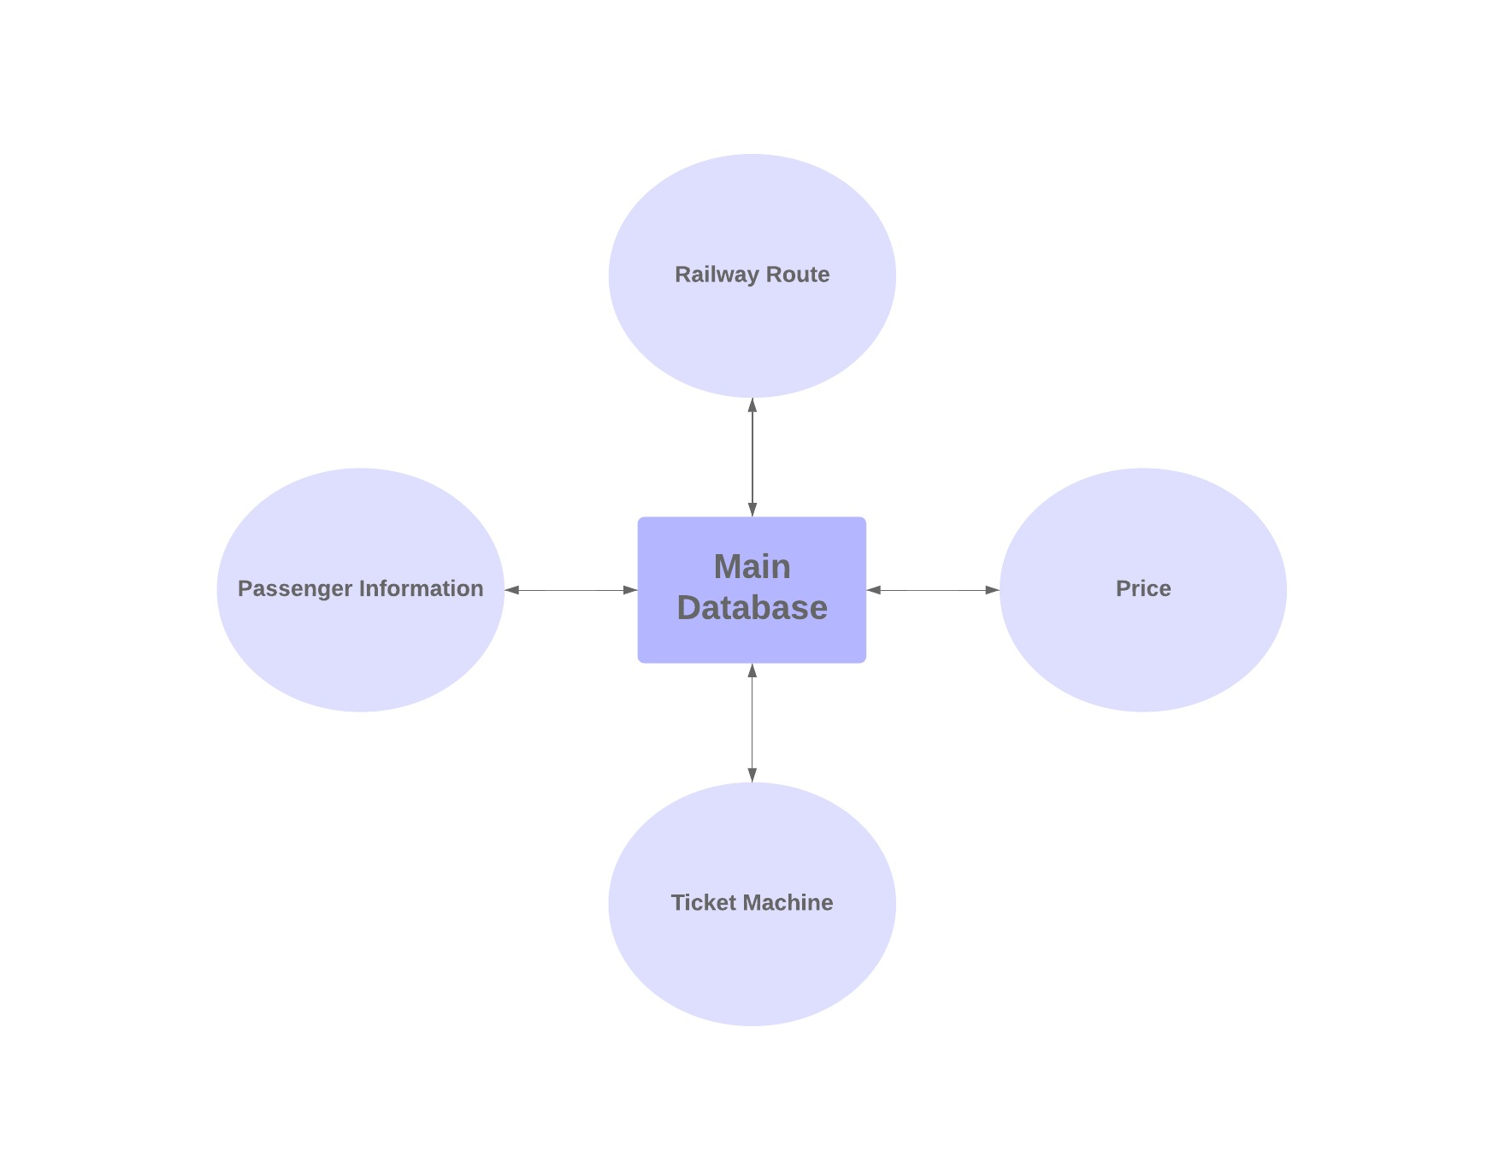

2b) **A 2D lunar lander video game. If you are not familiar with this game, search Lunar Lander Game online**

The architecture pattern known as Model-View-Controller should be utilized. Considering that is a game, the graphical display will continually change what the player (user) sees based on user inputs. The game will take these user inputs, recognize them, and manipulate the game in some shape or form. Upon completion, the view of the game will be updated and finally displayed onto the graphical display. Thus, the Model-View-Controller would be best suited for this game.

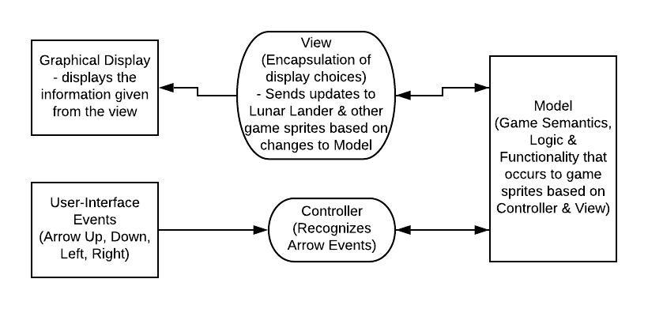

2c) **A robot floor-cleaner that is intended to clean relatively clear spaces such as corridors. The cleaner must be able to sense walls and other obstructions.**

The architecture pattern known as Sense-Compute-Control should be utilized. Sense-Compute-Control is typically used in embedded real-time control applications such as robotic control. Since the floor-cleaner is a robot, the architecture pattern remains relevant. Furthermore, response needs to be quick & implicit feedback from the external environment needs to be considered. Thus, Sense-Computer-Control is the obvious choice for the architecture pattern.

